Business Requirements Document (BRD)
Project — US Credit Card Lifecycle Analytics
Version: 1
Author: Dhruv Saxena
Last Updated: December 2025
Audience: Executive Sponsors, Product Owners, Data Governance, Risk & Analytics Teams, BI Developers, Compliance & Business Stakeholders

1. Executive Summary
The US Credit Card Lifecycle Analytics Project provides enterprise-grade dashboards and analytical assets to evaluate the current landscape of US credit card usage, debt levels, delinquency trends, collections performance, and risk segmentation.
The solution consolidates authoritative public datasets and supports lifecycle modelling to visualize consumer credit progression from spending and repayment behaviour to delinquency, default, and resolution.
Key business outcomes:
- Accelerate decision-making with real-time visibility on market risk trends.
- Support collections strategy evaluation and scenario planning.
- Provide lifecycle reporting for training, analysis, and operational optimization.
- Enable analytics without exposing individual-level or sensitive consumer information.

2. Background & Business Need
Risk leaders, analysts, and strategic stakeholders currently rely on fragmented public datasets with differing refresh cycles, limiting visibility into the full collections and charge-off lifecycle.
Additionally, training and portfolio-scenario testing are difficult due to lack of accessible lifecycle datasets.
This project solves these pain points by delivering:
- A consolidated executive dashboard for the US credit card market.
- A lifecycle analytics dashboard demonstrating account progressions (current → delinquency → default → resolution).
- Full documentation, governance, and usage guidelines.

3. Objectives & Success Criteria
Objectives
- Deliver two dashboards:
  - Market & Portfolio Overview (macro trends)
  - Lifecycle Analytics (account progression and outcomes)
- Provide KPIs and segmentation by state, age band, credit score tier, APR tier, and income group.
- Integrate transparent data provenance, quality ratings, and usage guidelines into dashboards.
- Enable drill-down capability and export of aggregated data views.
Measurable Success KPIs
- Manual reporting time reduced from 4–6 hours/week to <15 minutes/week.
- ≥ 85% stakeholder satisfaction in post-deployment feedback survey.
- ≥ 20 monthly active users within 60 days of rollout.
- Dashboard adoption by 3+ departments (Risk, Strategy, Collections, BI).
- SOX & governance compliance sign-off obtained before full release.

4. Scope
In Scope
- Executive Dashboard (regional, demographic and macro economic KPIs).
- Lifecycle Dashboard (payment behaviour → delinquency → default → resolution).
- Centralized data register with source coverage & quality ratings.
- Simulation-based scenario controls where applicable.
- Documentation pack for lineage, methodology and governance compliance.
Out of Scope
- Use of any individual or personally identifiable consumer information.
- Regulatory filings, loan underwriting, or eligibility assessment.
- Real-time operational system integration or credit-decision automation.

Flowchart
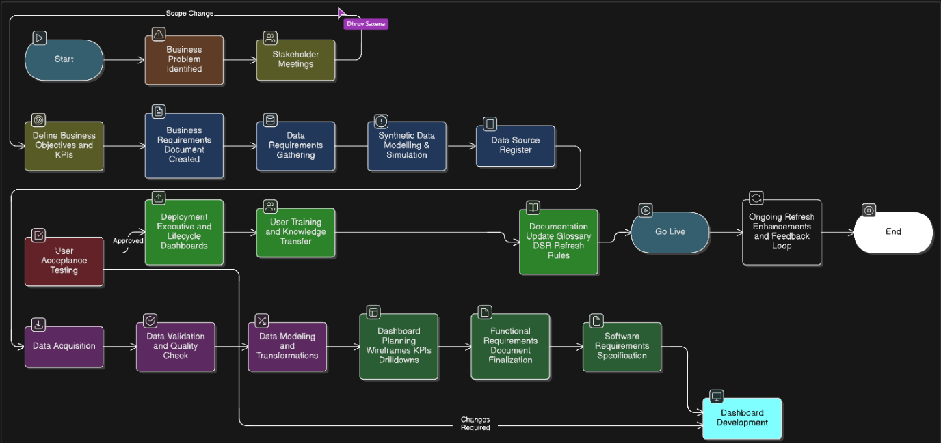

5. Stakeholders
Role | Responsibility
Executive Sponsor | Approvals & budget
Product Owner | Requirement prioritization & delivery oversight
Risk & Strategy Teams | Business logic & KPI validation
Data Engineering | ETL, data ingestion & infrastructure
BI / Dashboard Developers | Visualization, UX & deployment
Data Governance & Legal | Privacy & usage approval
QA Lead | Testing & acceptance validation

6. Business Requirements (BR)
ID | Business Requirement
BR-01 | Provide consolidated executive visibility into market debt, delinquency & APR trends
BR-02 | Enable lifecycle reporting across DPD buckets and collection outcomes
BR-03 | Allow state-level & demographic risk segmentation
BR-04 | Provide transparent metadata for every metric (source, coverage & quality)
BR-05 | Allow drill-through to aggregated underlying datasets without PII
BR-06 | Support export of aggregated views for reporting use
BR-07 | Implement RBAC for secure role-based dashboard access
BR-08 | Provide documentation and usage guidelines accessible from the UI

7. Functional Requirements (FR)
ID | Functional Requirement
FR-01 | Ingest and unify authoritative public datasets into a centralized analytics store
FR-02 | Store simulation datasets with metadata flag is_simulated = TRUE
FR-03 | Capture lineage metadata including ingestion timestamp, source ID & refresh frequency
FR-04 | Executive Dashboard to include KPI cards and time-series charts
FR-05 | Lifecycle Dashboard to include DPD transition flows and resolution outcomes
FR-06 | Support drill-down & export features for authorized users
FR-07 | Metadata/help panel embedded within dashboards
FR-08 | Role-based access control (Viewer / Analyst / Editor)
FR-09 | Dashboards optimized for desktop & tablet viewing

8. Non-Functional Requirements (NFR)
Category | Requirement
Performance | Dashboard KPIs load within 3 seconds; full visuals within 8 seconds
Availability | 99.5% uptime during business hours
Security | SSO + RBAC with export logging
Scalability | Support increasing dataset volume & scenario variations
Maintainability | ETL pipelines & dashboard mappings documented and version-controlled

9. Data Quality, Governance & Compliance
- Quality checks at ingestion (schema drift, null threshold, row count checks).
- Each source assigned a quality rating (Excellent / High / Good / Caution).
- Simulated datasets explicitly flagged; visible in dashboards and documentation.
- No PII handled or displayed; all records remain irreversible to individuals.
- Usage Restrictions: Dashboards are approved for internal reporting, training & strategy.
They must not be used for loan underwriting, consumer eligibility checks, financial disclosures, or regulatory filings.

10. Post–Go-Live Ownership
Area | Owner
Data pipeline refresh & ingestion | Data Engineering
Dashboard enhancements | BI Team
Governance oversight | Data Governance
User training & adoption | Product Owner
Issue escalation | BI Lead

11. Lifecycle / Decommission Plan
A review will be held annually to determine whether the dashboards should be:
- Continued with enhancements
- Replaced by an upgraded solution
- Decommissioned if adoption or business value declines
All decisions will be based on usage metrics, feedback, and operational dependencies.

12. Reporting & Deliverables
- Executive Dashboard (Macroeconomic & Risk Trends)
- Lifecycle Dashboard (Delinquency → Default → Recovery Analytics)
- Data Source Register
- Methodology & Calibration Document
- Deployment guide & refresh runbook
- UAT plan and final sign-off documents

13. Acceptance Criteria
A solution will be accepted when:
- All BR and FR requirements pass UAT
- KPI validation matches source data within tolerance
- All simulated visualizations are clearly labeled
- Performance SLAs are met
- Access controls and export permissions function correctly
- Stakeholders (Product Owner, Risk Lead, Data Governance & Executive Sponsor) sign off

14. Risks & Mitigation
Risk | Mitigation
Simulated data may be mistaken for real indicators | Visual flags, metadata & tooltip notices
Data refresh mismatch across sources | Display “as-of” dates for all KPIs
Performance degradation | Use aggregated materialized tables
Security breach | RBAC, export audit logs, legal review

15. Assumptions
- Access to authoritative public datasets will remain available.
- No PII or consumer-level transactional data will ever be processed.
- Stakeholders will participate in UAT and provide timely feedback.
- Adoption targets will be tracked after go-live.

16. Appendix A — Condensed Data Source Register (Summary)
Source | Coverage | Type | Quality | Used For
FRED — DRCCLACBS | 1991–2025 | Authoritative | Excellent | Delinquency trend
NY Fed — Household Debt & Credit | 2003–2025 | Authoritative | Excellent | Debt & balance KPIs
Experian — Credit Card Statistics | 2024 | Authoritative | Excellent | APR & demographic segmentation
Visual Capitalist — State Delinquency | 2025 | Derived | High | Geographic heatmaps
CFPB — Complaint Database | 2011–2025 | Authoritative | High | Consumer pain points
Internal Simulation Datasets | 2025 | Statistical | High | Lifecycle modelling & scenario testing

17. Appendix B — Glossary
- APR: Annual Percentage Rate
- DPD: Days Past Due
- RBAC: Role-Based Access Control
- UAT: User Acceptance Testing
- MAU: Monthly Active Users

